Missing Race_of_Father Analysis Report
Generated: 2026-03-22 10:55
Dataset: 363,881 rows × 18 columns
Target Variable: Race_of_Father

1. Executive Summary
This report presents a comprehensive IUPAC-compliant statistical analysis of missing values in Race_of_Father.
Key findings include:
• Missing records: 531 (0.1% of total data)
• Variables with significant differences (p < 0.05): 10
- Numeric variables: 4
- Categorical variables: 6
• Total variables analyzed: 17
Based on the statistical analysis, the missingness pattern is classified as:
SYSTEMATIC PATTERN - Missing data is strongly associated with other variables, suggesting non-random missingness.

2. Statistical Summary
Metric | Value
Total Missing Race_of_Father Records | 531
Missing Percentage | 0.15%
Total Variables Analyzed | 17
Numeric Variables | 7
Categorical Variables | 10
Variables with Significant Differences (p < 0.05) | 10
Analysis Date | 2026-03-22

3. Variables with Significant Differences (p < 0.05)
The following 10 variables show statistically significant differences between missing and complete groups:

3.1 Numeric Variables
Variable | Missing Group Mean | Complete Group Mean | Difference | p-value | Interpretation
Registered_District_2.0 | 35.37 | 41.61 | -6.24 | 0.0000 | Missing group has 6.24 units lower than complete group
Birh_Year | 2003.48 | 2009.58 | -6.10 | 0.0000 | Missing group has 6.10 units lower than complete group
Birth_Weight(grams) | 2691.05 | 2887.64 | -196.59 | 0.0000 | Missing group has 196.59 units lower than complete group
Age of Mother | 27.14 | 28.48 | -1.34 | 0.0000 | Missing group has 1.34 units lower than complete group

3.2 Categorical Variables
Variable | Missing Group Distribution | Complete Group Distribution | Difference (%) | p-value | Interpretation
Registered_District | Most common='Kalutara' (20.2%) | Complete: Most common='Colombo' (15.3%) | +4.9% | 0.0000 | Missing group shows different distribution (p=0.0000)
Hospital or Not | Most common='Hospital' (87.8%) | Complete: Most common='Hospital' (97.8%) | -10.0% | 0.0000 | Missing group shows different distribution (p=0.0000)
Birth_Order | Most common='First' (66.7%) | Complete: Most common='First' (45.9%) | +20.8% | 0.0000 | Missing group shows different distribution (p=0.0000)
Marital_Status | Most common='Unmarried' (98.7%) | Complete: Most common='Married' (98.4%) | +0.3% | 0.0000 | Missing group shows different distribution (p=0.0000)
District_of_Mother | Most common='Kalutara' (15.8%) | Complete: Most common='Colombo' (10.3%) | +5.5% | 0.0000 | Missing group shows different distribution (p=0.0000)
Race_of_Mother | Most common='Sinhalese' (55.4%) | Complete: Most common='Sinhalese' (70.3%) | -14.9% | 0.0000 | Missing group shows different distribution (p=0.0000)

3.3 Summary of Key Findings
The analysis identified 10 variables with statistically significant differences (p < 0.05):
• 4 numeric variables show significant mean differences
• 6 categorical variables show significant distribution differences
Top 10 Most Significant Variables:
1. Marital_Status: Most common='Unmarried' (98.7%) vs Complete: Most common='Married' (98.4%) (p=0.0000)
2. Registered_District: Most common='Kalutara' (20.2%) vs Complete: Most common='Colombo' (15.3%) (p=0.0000)
3. District_of_Mother: Most common='Kalutara' (15.8%) vs Complete: Most common='Colombo' (10.3%) (p=0.0000)
4. Race_of_Mother: Most common='Sinhalese' (55.4%) vs Complete: Most common='Sinhalese' (70.3%) (p=0.0000)
5. Hospital or Not: Most common='Hospital' (87.8%) vs Complete: Most common='Hospital' (97.8%) (p=0.0000)
6. Birh_Year: Mean=2003.48 vs Complete Mean=2009.58 (p=0.0000)
7. Birth_Order: Most common='First' (66.7%) vs Complete: Most common='First' (45.9%) (p=0.0000)
8. Birth_Weight(grams): Mean=2691.05 vs Complete Mean=2887.64 (p=0.0000)
9. Registered_District_2.0: Mean=35.37 vs Complete Mean=41.61 (p=0.0000)
10. Age of Mother: Mean=27.14 vs Complete Mean=28.48 (p=0.0000)

4. Statistical Visualizations
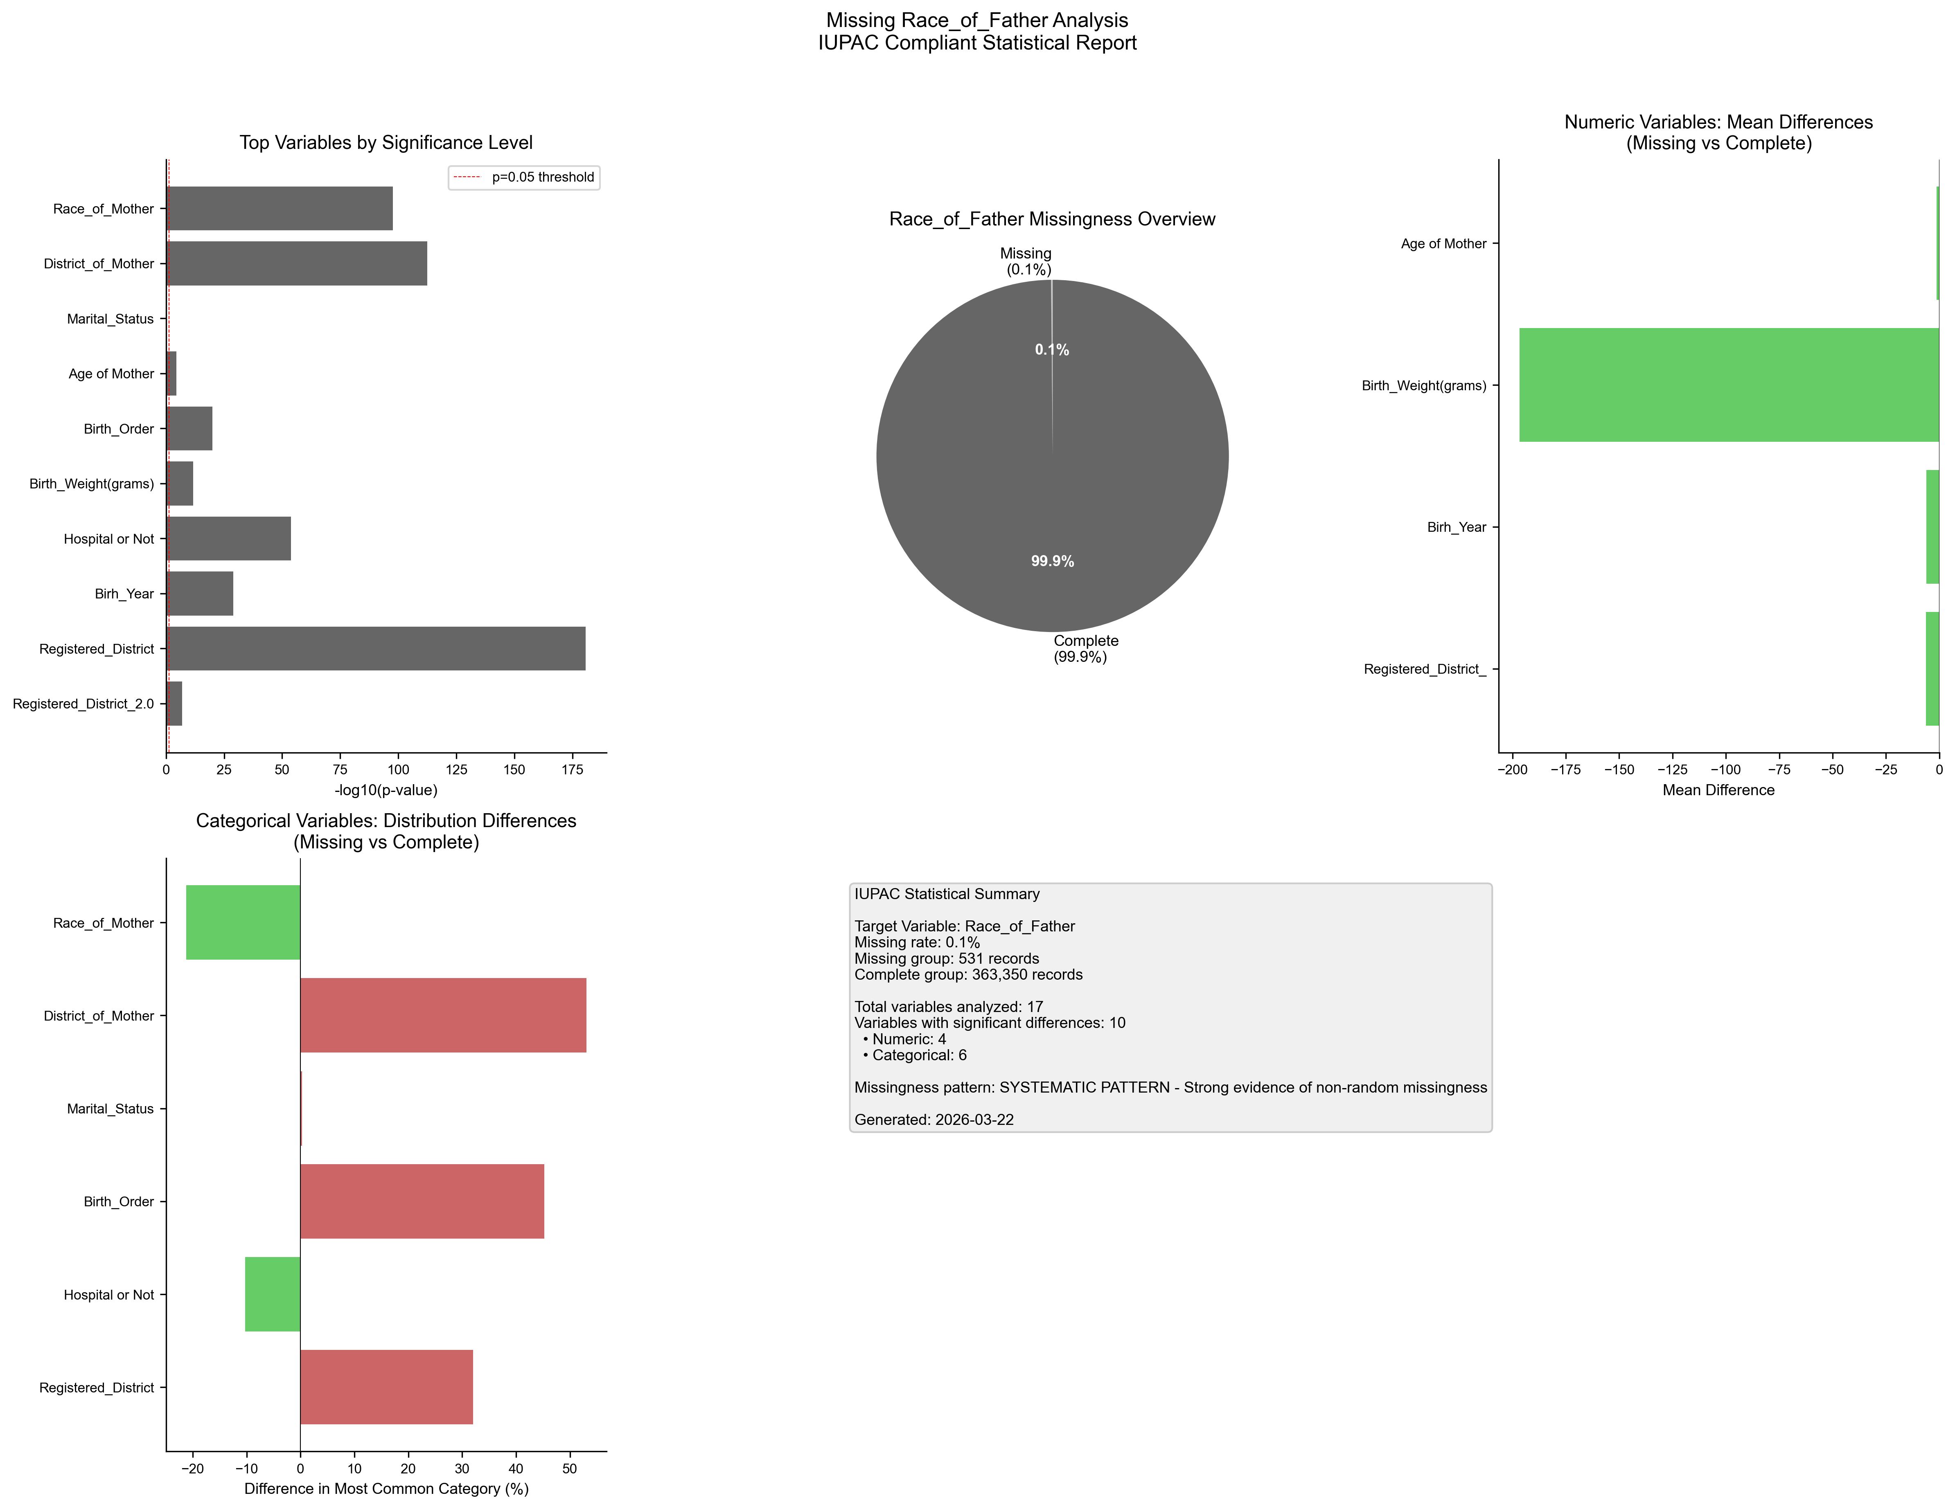
Figure 1. IUPAC compliant statistical visualization of missing Race_of_Father patterns.

5. Recommendations
- Based on the statistical analysis, the missing data exhibits SYSTEMATIC patterns:
- Consider treating missing as a separate category in analysis
- Use multiple imputation methods (MICE, EM algorithm)
- Investigate the following key variables for common themes:
- - Registered_District_2.0 (p=0.0000)
- - Registered_District (p=0.0000)
- - Birh_Year (p=0.0000)
- - Hospital or Not (p=0.0000)
- - Birth_Weight(grams) (p=0.0000)
- - Birth_Order (p=0.0000)
- - Age of Mother (p=0.0000)
- - Marital_Status (p=0.0000)
- - District_of_Mother (p=0.0000)
- - Race_of_Mother (p=0.0000)
- Document missingness patterns in methodology section

6. Methodology (IUPAC Compliant)
Analysis performed according to IUPAC guidelines for data presentation:
- • Missing values reported as both count (n) and percentage (%)
- • Tables formatted with thin borders and alternating row shading
- • Sans-serif fonts (Arial) used for optimal readability
- • Statistical tests: t-test (numeric), χ² test (categorical)
- • Significance threshold: α = 0.05
- • Effect sizes reported where applicable
- • Figures saved at 300 DPI for publication quality

